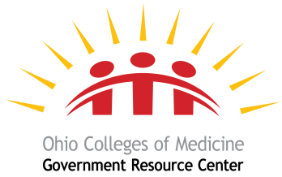

The Ohio Colleges of Medicine Government Resource Center
SIM Self-Evaluation

The Ohio Colleges of Medicine Government Resource Center (GRC) will develop and implement the State Innovation Model (SIM) Self-Evaluation. The SIM Self-Evaluation will utilize qualitative and quantitative data to evaluate the implementation, cost-effectiveness, and impact of both the Comprehensive Primary Care (CPC) delivery and payment model and the statewide Episode-Based payment model. GRC, in consultation with an advisory group that includes ODM, health plans, provider associations, HSAG, and other subject matter experts (i.e., systems analyst and economist), will design, implement, review, and produce the SIM Self-Evaluation deliverables. In addition to project development and implementation, GRC will provide project management, research, administrative, and fiscal support to the project. GRC will work collaboratively with ODM and stakeholders to implement the SIM-Self Evaluation for the Comprehensive Primary Care (CPC) delivery and payment model and the statewide Episode-Based payment model. GRC will also conduct a qualitative analysis of SIM model design.
The SIM Self-Evaluation will provide ODM with snapshots of the status of population health, health systems transformation, and cost trend patterns statewide. GRC will analyze the relevant impacts of the SIM model and its implementation by geography and subpopulations, with an emphasis on health disparities. Analytics will include service utilization, expenditure, cost-effectiveness, and impact findings in addition to quantitative and qualitative data collection and analyses with descriptive statistics, modeled statistics, meta-data analyses (i.e., process comparisons), and qualitative coding using predominant theme techniques (i.e., theme prioritization).
The comprehensive SIM Self-Evaluation will consist of three elements:
- Qualitative analyses of the SIM Model Design Process
- Episode-based payment evaluation
- Ohio CPC evaluation

For each element, GRC will document activities under the models, document variation in design, approach, and innovation of those activities; identify opportunities for continuous improvement; examine how the program contributed to advancing the state’s goals; and identify lessons learned for program sustainability. This may include topics relevant to sustainability planning, including: governance/oversight, financing, stakeholder engagement, infrastructure, measurement, transparency, multi-payer reform, HIT/HIE, legislation and policy, workforce, population health, and Medicare participation.

